



Test Document
Simply Rugby System
Contents
1. Test Document Overview 3
• Purpose of the Document 3
2. Manual System Testing 3
• Test Strategy 3
• Testing 3
• Test Remediation 7
3. Junit Automated Unit 7
• Test Strategy 7
• Automated Tests 7
4. Manual GUI Testing 8
• Test Strategy 8
• User Testing 8
5. Test Document Summary 9
• Advantages and Disadvantages of Unit Testing & Manual GUI Testing & Manual Testing 9

Test Document Overview

Purpose of the Document
The purpose of this test document is to examine the application for potential unexpected behaviours that could negatively affect its performance. We will look at three types of testing: Manual System Testing, JUnit Automated Unit Testing, and Manual GUI Testing. For each of these, a testing strategy and a detailed test plan will be presented. This document includes test cases, test data, expected and actual results, as well as all actions aimed at fixing malfunctioning methods and components. Furthermore, it presents an analysis of the test results and the identification of issues, along with retesting after implementing fixes.
The document show evidence of a comprehensive testing process that concentrates on ensuring that the software meets all project requirements, both functional and non-functional.

Manual System Testing

Test Strategy
Manual Testing involves manually verifying the operation of all key application functions from the end users perspective. This test document will mostly focus on functional testing, also known as black box testing, which means that the tester focus on inputs and expected outputs without any knowledge of the internal code structure. The tests include both valid and invalid data to ensure the application responds correctly in various scenarios. Any encountered bugs or undesired behaviours are documented, and retesting is performed after each fix.

Testing
Test Plan
Candidate: Kamil Milej Project Title: Simply Rugby System

Test Case ID | Test Case Function | Test case | Test Steps | Expected result | Post Condition | Actual result | Comments / Status
TLV01 | Login Validation | Test valid login | - Enter valid User ID and password  - data test : kmilej/codingishard  -Click "Login" | Login successful, user/Coach logged in | Show Main Menu | As expected | 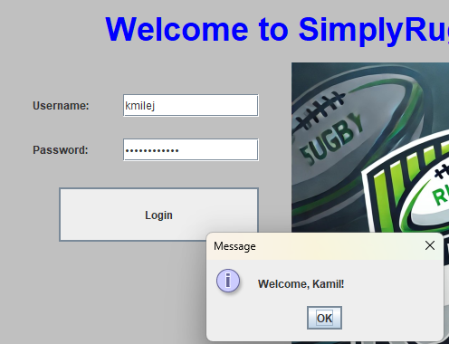
TLV02 | Login Validation | Test empty login | 1. Enter empty User ID and password  2. Click "Login" | Error show | Login screen | As expected | 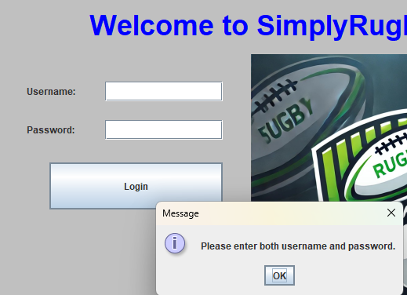
TLV03 | Login Validation | Test invalid login/password | 1. Enter invalid User ID and invalid password  2. Click "Login" | Error show | Login screen | As expected | 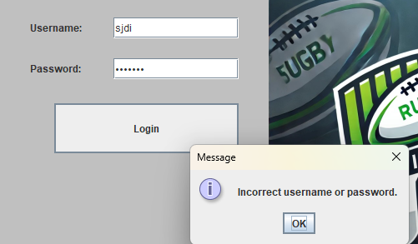

Test Case ID | Test Case Function | Test case | Test Steps | Expected result | Post Condition | Actual result | Comments / Status
TLV04 | Login Validation | Test invalid login | 1. Enter invalid User ID and empty password  2. Click "Login" | Error show – please enter both user and password | Login screen | As expected | 
TGUI01 | Application launch correct UI layout, login screen | interface elements are displayed correctly | 1. Launch the application  2. Wait for the main view to fully load | All interface elements fits the screen resolution | Login screen show | As expected | Verify that all interface elements are displayed correctly and nothing overlaps upon launching the application
TGUI02 | Dynamic Coach loading | Verify that the Coach name is displayed dynamically when logged in | 1.Login into main manu screen | The coach sees his name after logging in on the main menu screen | Dynamic name change depends on who logs in | As expected | 
TGUI3 | Display list of all coaches | Verify that clicking the "Active Coaches" button displays a list of all coaches | 1.Login into main manu screen  2.Click the "Active Coaches" button | A list of all coaches is dynamically displayed | List of coaches is visible and readable in window | As expected | 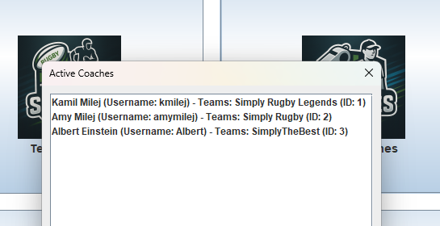
TGUI4 | Display list of all teams in Simply Rugby | Verify that clicking the "Teams in club" button displays a list of all teams | 1.Login into main manu screen  2.Click the "Teams in club" button | A list of all teams is dynamically displayed | List of teams is visible and readable in window | As expected | 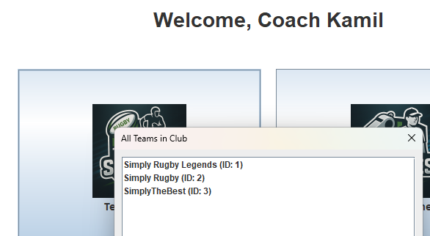
TGUI05 | Exit application from main menu | Verify that clicking the "Exit" button on the main menu closes the application | 1.Login into main manu screen  2.Click the "Exit" button | The application closes completely without errors | Application is no longer running | As expected | 
TGUI06 | Display My Teams menu | Verify that clicking My team button will change to My team screen | 1.Login into main manu screen  2.Click the "My Teams" button | Change screen to My Teams without errors | Screen changed correctly | As expected | 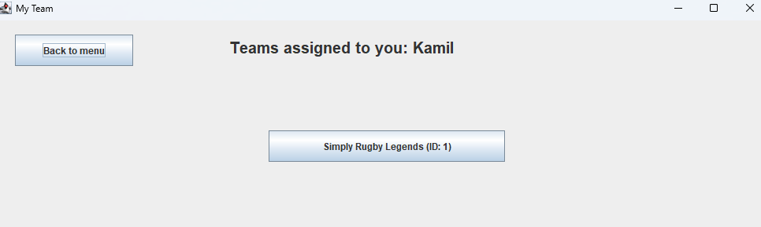
TGUI7 | Display assigned team for selected coach | Verify that selecting a coach displays the team assigned to them | 1.Login into main manu screen  2.Click the "My Teams" button | A list of teams assigned to the selected coach is displayed | Team is visible and correctly linked to the selected coach | As expected | 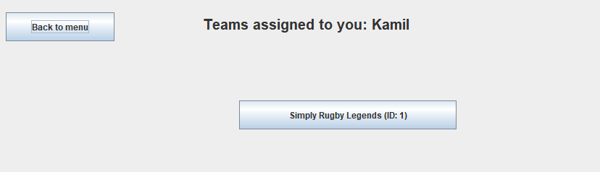

Test Case ID | Test Case Function | Test case | Test Steps | Expected result | Post Condition | Actual result | Comments / Status
TGUI08 | Back to Menu | Verify that clicking the "Back to Menu" button navigates the Coach to the main menu screen | 1.Login into main manu screen  2.Click the "My Teams" button  3. press “back to menu” button | Screen change to the main menu screen without errors | Main menu is displayed and fully functional | As expected | 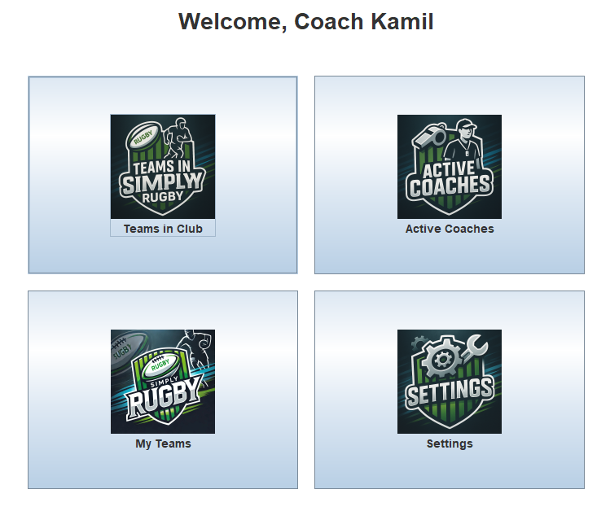
TGUI09 | Navigation from My Team to Player Menu | Verify that clicking on the assigned team in the "My Team" screen changes the view to the "Player Menu" screen | 1.Login into main manu screen  2.Click the "My Teams" button  3. Click assigned team | The screen changes to the "Player Menu" screen, showing options or details for managing players | Player Menu screen show,  My team screen closes | As expected | 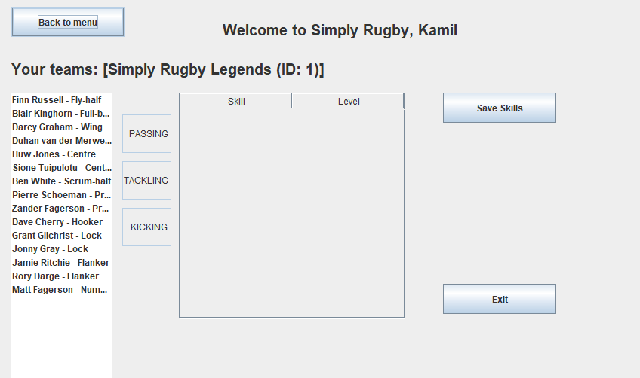
TGUI10 | Back to Menu in player menu screen | Verify that clicking the "Back to Menu" button navigates the Coach to the main menu screen | 1.Login into main manu screen  2.Click the "My Teams" button  3. Choose assigned team  4. press “back to menu” button | Screen change to the main menu screen without errors | Main menu is displayed and fully functional | As expected | 
TGUI11 | Dynamic display of selected team | Verify that selected team displays in player Menu dynamically | 1.Login into main manu screen  2.Click the "My Teams" button  3. Choose assigned team | The selected team is displayed immediately in the interface | Your teams : (name of assigned team) and id | As expected | 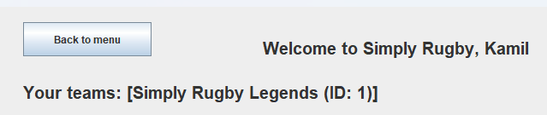
TGUI12 | Player selection | Verify that selecting a player from the list show data for further actions | 1.Login into main manu screen  2.Click the "My Teams" button  3. Choose assigned team  4. choose player form the list | In table in the middle should show skill statistics | Show eleven stats inside table | As expected | 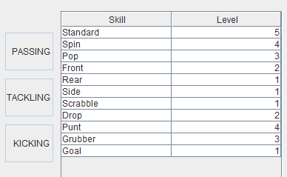

Test Case ID | Test Case Function | Test case | Test Steps | Expected result | Post Condition | Actual result | Comments / Status
TGUI13 | Change player | Verify if we change a player on list will not show any error and application will show currect information | 1.Login into main manu screen  2.Click the "My Teams" button  3. Choose assigned team  4. choose player form the list  5. change player from the list to another one. | Another player will displayed correctly without errors | Another player skill table show without errors | As expected | 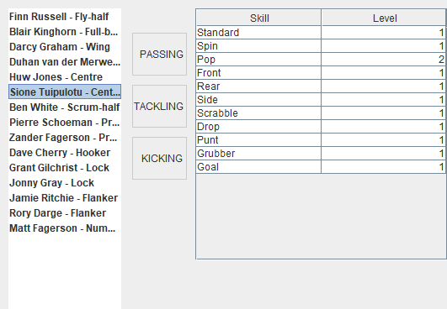
TGUI14 | change player skill attributes | Verify that a selected player's skill data can be change | 1.Login into main manu screen  2.Click the "My Teams" button  3. Choose assigned team  4. choose player form the list  5. change statistic | New data will show after change it | New skill values are visible in table | As expected | 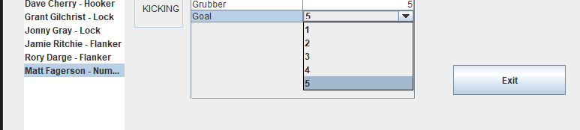
TGUI15 | change player skill attributes and save | Verify that a selected player's skill data can be change and save successfully | 1.Login into main manu screen  2.Click the "My Teams" button  3. Choose assigned team  4. choose player form the list  5. change statistic  6. Press “Save Skills | All changes should be save, also the message should show - skills saved to file | New skill values are visible and stored in the system | As expected | 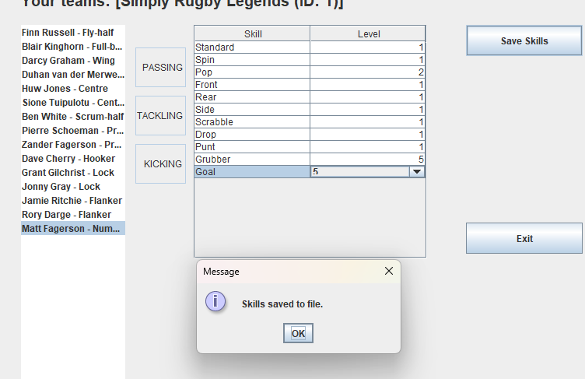
TGUI16 | Save opportunity with exit button | After changes few players and not save by “save skills” button, exit save opportunity | 1.Login into main manu screen  2.Click the "My Teams" button  3. Choose assigned team  4. choose player form the list  5. Change statistic  6. Press “exit” button | After change statistic in few player and press exit the “exit confirmation “ will show with opportunity to save all changes in all player or exit without save | If yes, all players skills are saved  else exit without save any changes. | As expected | 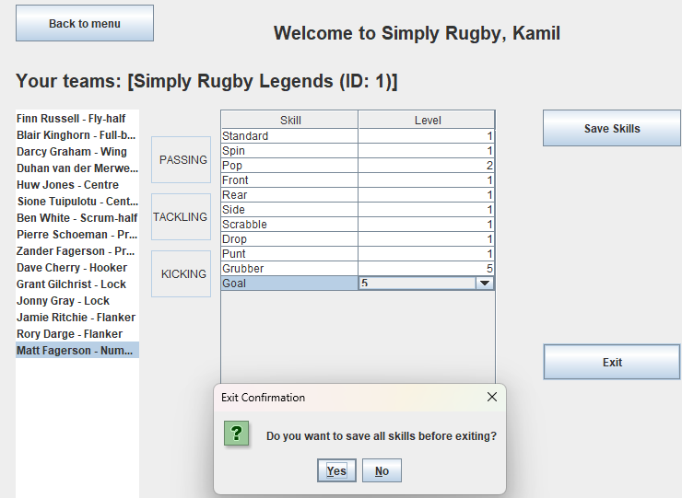

Test Remediation
Test remediation was not required because, at the stage when this document was created, all issues were being addressed and fixed on an ongoing basis in accordance with the project requirements. There were earlier problems that are not recorded here, but those occurred before the creation of the test documentation.

Junit Automated Unit

Test Strategy
In my Simply Rugby application prototype, automated unit tests are made using JUnit 5. The goal is to verify the correctness of methods in classes such as Coach, Team, and Player. These tests focus on small portions of the code and evaluate their behaviour in various scenarios. Positive and Negative Testing: For each component, both valid cases (e.g., correct login data, adding a player) and invalid cases (e.g., incorrect password, exceeding skill range) are tested. Good practices for unit tests include, for example:
They should be isolated, meaning tests do not depend on the graphical user interface or external data sources.
They should be readable, meaning the test name should be understandable just by reading it.

Automated Tests

No | Test Name | Description | Pass | Fail
CoachLoginTest
1 | testCorrectCredentials() | Tests that the login is successful when correct credentials are provided. | The system returns a non-null Coach object with the expected username. | The system returns null or a Coach object with a different username.
2 | testWrongPassword() | Tests that login fail when incorrect password is provided for an existing user. | The system returns null – because we use assertNull | The system returns a non-null Coach object
3 | testUnknownUsername() | Tests that login fail when both the username and password are empty - “”. | The system returns null | The system returns a non-null Coach object.
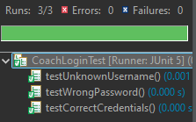

No | Test Name | Description | Pass | Fail
PlayerTest
4 | testDefaultSkillsInitialized() | Tests that a new created player has all 11 skills initialised to level 1 by default. | The skills map contains 11 entries, and all skill levels are set to 1 | The map contains a different number of skills, or one or more skills have an incorrect default level.
5 | testSetValidSkillLevel() | Tests that a valid skill level can be set for a specific skill ("Drop") | Skill successfully updated to 4 | Skill drop remains unchaneged or is set incorrect value
6 | testSetInvalidSkillLevel() | Tests that setting an invalid skill level (e.g., 7, which is out of the allowed range) does not change the original value. | If value from 1 still will be 1 and not change to 7 | If change to an invalid value, in this case 7
7 | testSetSkillForNonexistentSkill() | Test attempting to set fot nono existent skill e.g. UnrealSkill does not throw an exception | No exception is thrown – (exception is not implemented) | An exception is thrown when trying to set the skill
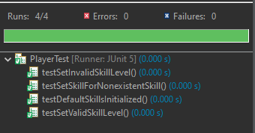
No | Test Name | Description | Pass | Fail
TeamTest
8 | testAddAndGetPlayers() | Tests a player if can be successfully added to a team and retrieved from the team's player list. | The teams player list contains exactly one player that matches the added player. | The player is not added correctly, or the list is empty or contains incorrect data.
9 | testTeamIdAndName() | Tests a team if is correctly initialised with the given ID and name. | Getter methods getId() returns "99" and getName() returns "Winners United" | he returned ID or name is incorrect.
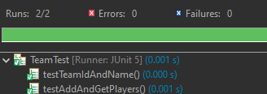

Manual GUI Testing

Test Strategy
Manual GUI testing was conducted by a volunteer to identify any elements that may have been overlooked during the software development process. The person was asked to navigate through the application and answer fundamental questions related to its functionality. This test covered all the features that the prototype is intended to support for daily use.

User Testing

Tester Name : Edyta Milej
She used provided account and password : kmilej // codingishard
Does the Application turn on? | Yes ☒ No ☐
Can you log in to the provided account? | Yes ☒ No ☐
Is the interface easy to navigate? | Yes ☒ No ☐
Do you see after clicking all coaches and teams | Yes ☒ No ☐
Do Can you go into your team | Yes ☒ No ☐
Can you change the Skill parameter and save? | Yes ☒ No ☐
Can you exit the application? | Yes ☒ No ☐

Test Document Summary

Advantages and Disadvantages of Unit Testing & Manual GUI Testing & Manual Testing

Testing Type | Advantage | Disadvantages
Unit Testing | Early error detection, simplifies debugging,  Fast and automated | Tests small parts of code,  cant test interface,  good knowledge about code
Manual GUI Testing | Simulate real user behavior,  Helps catch UI/UX issues,  No required any programming | Time-consuming,  Hard to repeat consistently,  Not scalable in large projects
Manual Testing | Gives flexibility in various case,  Intuitive/logic,  doesn’t require additional tools | Slower than automated testing  Hard to maintain in large system,  It costs a lot if you need a lot of tests

